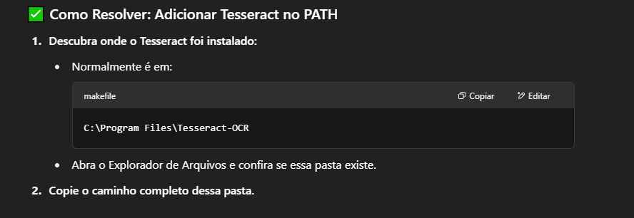
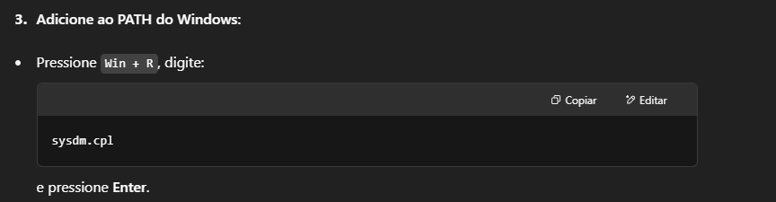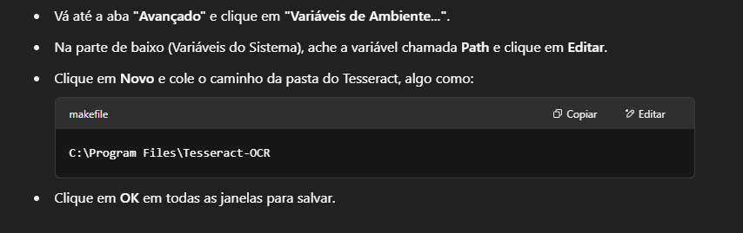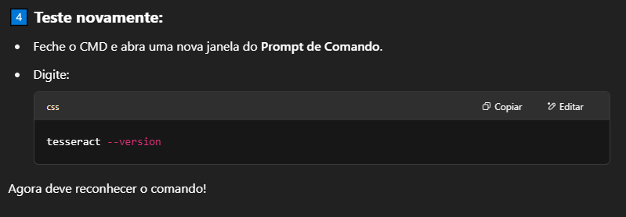

sysdm.cpl
C:\Program Files\Tesseract-OCR
tesseract --version

